HIERARCHICAL CLUSTERING
Drawback of K-Means
Calculate distance from centroids

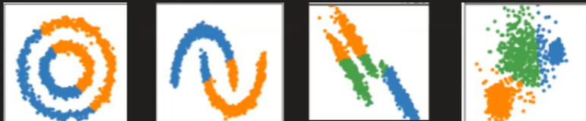

Need to know the value of k

K- Means only works best with data having separate spherical shapes

2 Type of Hierarchical clustering
- Agglomerative
- Divisive
Dendogram

Algorithm
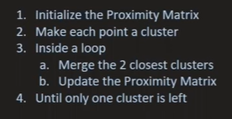

 | P1 | P2 | P3 | P4 | P5
P1 | 0 | - | -
P2 |  | 0
P3 |  |  | 0
P4 |  |  |  | 0
P5 |  |  |  |  | 0

 | P1 | P2 | C1 | P5
P1
P2
C1
P5

Repeat the process until only

Distance between the points can be calculated using Euclidian distance
How can we calculate the between clusters?

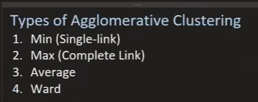

Single Link (Min)

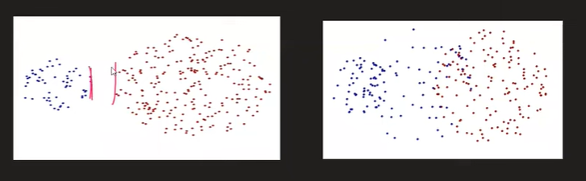

Complete Link (Max)

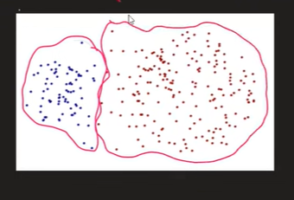

Average Link
D1+d2+d3+d4+d5+d6/6

Ward Link
C12 + C22+C32+C42-A12 – A22-B12-B22

It’s the default value in sklearn

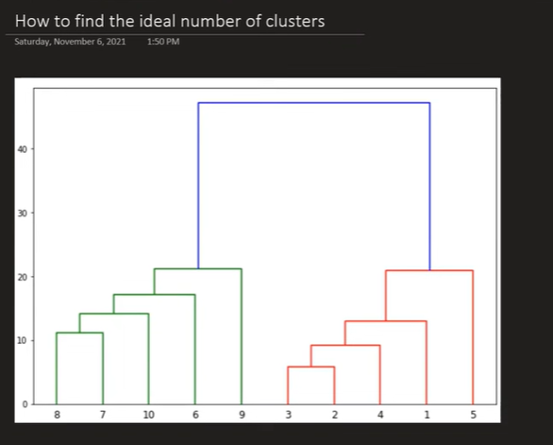

We need to find the longest vertical line

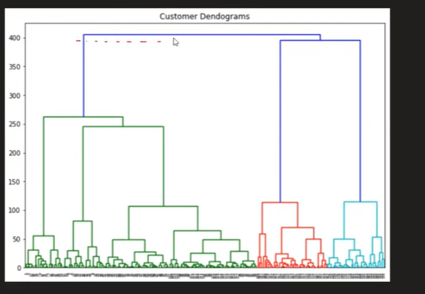

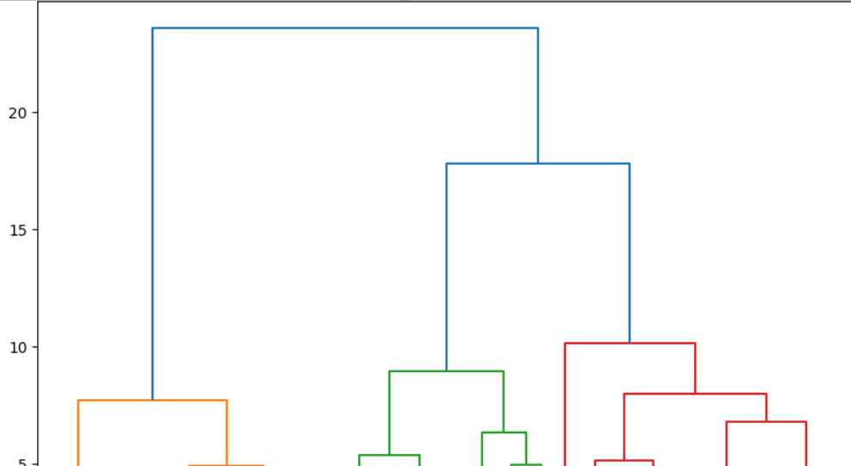

Hyperparameters
N_clusters =3 (number of clusters)
metric = Euclidian
Linkage = ward
Distance_threshold

Quiz Questions

1. Hierarchical clustering primarily differs from k-means because it:
A. Requires specifying the number of clusters in advance
B. Produces a tree-like structure of clusters
C. Uses centroids to form clusters
D. Works only with numerical data

2. In agglomerative hierarchical clustering, the process begins with:
A. One large cluster
B. Randomly assigned clusters
C. Each data point as its own cluster
D. The number of clusters defined by the user

3. Divisive clustering is also known as:
A. Top-down clustering
B. Bottom-up clustering
C. Distance-based clustering
D. Non-hierarchical clustering

4. Which linkage method considers the maximum distance between points of different clusters?
A. Single linkage
B. Complete linkage
C. Average linkage
D. Ward’s method

6. The diagram created in hierarchical clustering to show merging/splitting is called:
A. Histogram
B. Heatmap
C. Dendrogram
D. Scatter plot

10. To determine the optimal number of clusters using a dendrogram, we:
A. Look for the largest vertical distance without merges
B. Count the number of leaves
C. Use gradient descent
D. Select clusters based on centroid positions

